### **Project Design Phase-II**

### **Data Flow Diagram & User Stories**

**Date**: April 14, 2025

**Team ID**: SWTID1743607143

**Project Name**: BookEase

**Maximum Marks**: 4 Marks

### **Data Flow Diagrams**

A Data Flow Diagram (DFD) is a traditional visual representation of the information flows within a system. A neat and clear DFD can depict the right amount of the system requirement graphically. It shows how data enters and leaves the system, what changes the information, and where data is stored.  
  
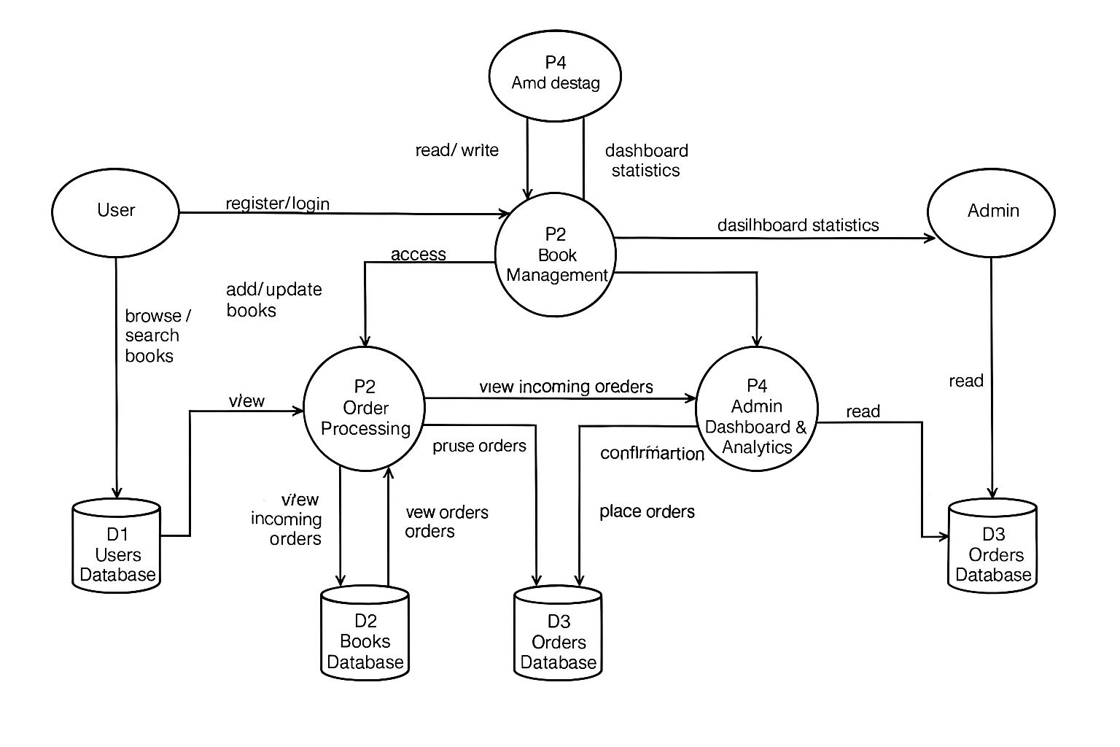

**BookEase DFDs:**

**Level-0 Description:**

* User: The end-user who interacts with the BookEase web app.
* Seller: The seller who manages book inventory.
* Admin: The administrator who oversees users and sellers.
* Process Order: Handles order requests from users, processes payments, and updates order data.
* Manage Books: Manages book catalog updates from sellers and browsing by users.
* Admin Actions: Handles user and seller management by admins.
* Book Data: Database storing book information.
* User Data: Database storing user and seller information.
* Order Data: Database storing order details.

**Level-1 Description and Processes:**

* User: The end-user who interacts with the BookEase web app.
* Seller: The seller who manages book inventory.
* Admin: The administrator who oversees users and sellers.
* Book Data: Database storing book information.
* User Data: Database storing user and seller information.
* Order Data: Database storing order details.
* Processes:
  + User Interface (UI): Manages user, seller, and admin interactions with the web app, including homepage sparkles.
  + Authentication: Handles login and registration processes, updates user data.
  + Order Processor: Manages order placement, updates order data.
  + Book Manager: Handles book browsing and seller updates, updates book data.
  + Admin Controller: Processes user and seller deletion, updates user data.

### 

### **User Stories**

| **User Type** | **Functional Requirement (Epic)** | **User Story Number** | **User Story / Task** | **Acceptance Criteria** | **Priority** | **Release** |
| --- | --- | --- | --- | --- | --- | --- |
| Customer (Web user) | User Management | USM-1 | As a user, I want to register for the application by entering my email and password. | I can provide email and password and access my account. | High | Sprint 1 |
| Customer (Web user) | User Management | USM-2 | As a user, I want to log in to the application by entering my email and password. | I can enter credentials and access my dashboard. | High | Sprint 1 |
| Customer (Web user) | Book Management | USM-3 | As a user, I want to browse the book catalog. | I can view book titles, authors, and prices. | High | Sprint 1 |
| Customer (Web user) | Cart and Orders | USM-4 | As a user, I want to add items to my cart and place an order. | I can add books to cart and complete an order. | Medium | Sprint 2 |
| Customer (Web user) | Cart and Orders | USM-5 | As a user, I want to view my order history. | I can see a list of past orders. | Medium | Sprint 2 |
| Seller (Web user) | Book Management | USM-6 | As a seller, I want to add books to the catalog. | I can upload book details and images. | Medium | Sprint 2 |
| Admin (Web user) | Admin Management | USM-7 | As an admin, I want to view a list of users and sellers. | I can see user and seller details. | High | Sprint 1 |
| Admin (Web user) | Admin Management | USM-8 | As an admin, I want to delete users or sellers. | I can delete entries with a confirmation message. | High | Sprint 1 |